This document describes usage and configuration of Internal Government of Alberta Electronic Signatures for use on Internal Forms.

Use Your Digital ID

Before using digital signatures, please ensure that you have read and understand the Government of Alberta Digital Signature Policy located at the following link:
http://imtdocs.alberta.ca/standards/electronic-signature-metadata-1.aspx

Shortcuts for help with these additional topics:
Check Your Available Digital Signatures
Create a Certified Government of Alberta Electronic Signature
Validate a Signature
Configure Adobe Reader to Trust GoA Certificates
Manually Trust a Signature

Click on the field that you would like to apply the digital signature. If there is only one signature created, it will pop up saying that this will be the signature used. If there are multiples, it will show you a list of all the signatures in the “Sign As” drop down list. You are then able to choose the correct one to apply:
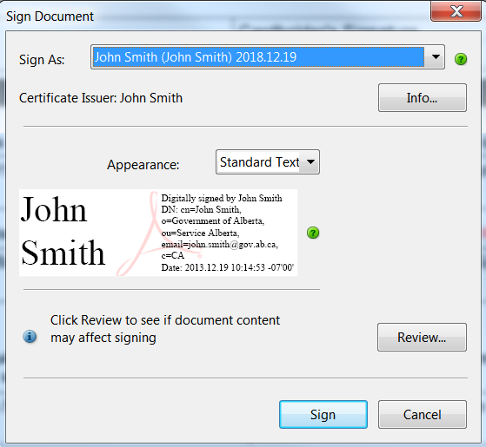

Once you have chosen the correct signature, choose “Sign”. When you do this it will prompt you for a location to save your signed document – choose a different name from the current file name that you are saving your document as, and make your location selection and hit “Save”.

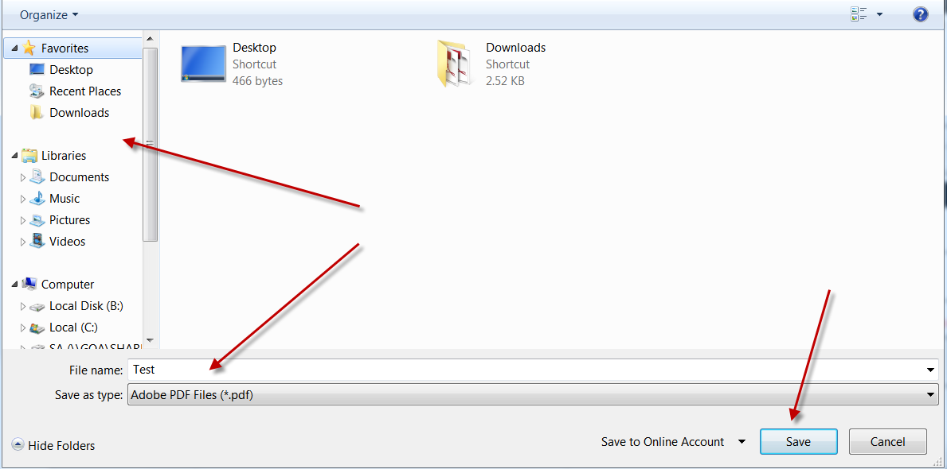

Your signature will appear like this on the document:

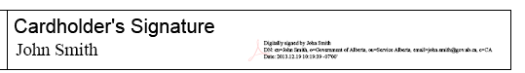

Check your available Digital Signatures
- Click on your Windows key (found at the bottom left of your task bar).

- In the “Type here to search” type “Manage computer certificates” and click the best match
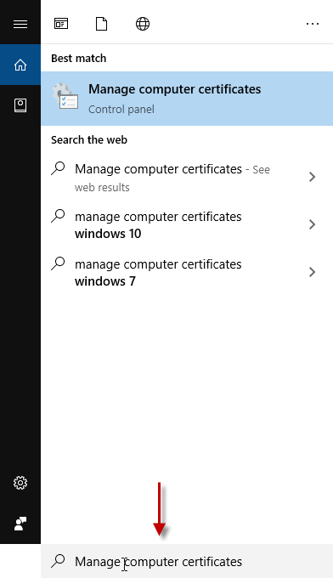

- The following window will open – Click on the Personal folder.

- The following window will appear.
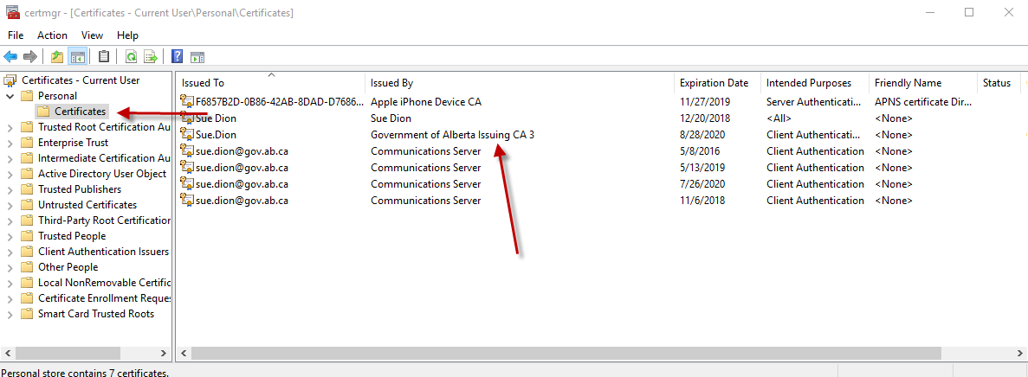

- Click on Certificates folder and you will see all your certificates.
- The certificate that you will use will be the “Government of Alberta Issuing CA #” certificate.
IF YOU DO NOT HAVE A “GOVERNMENT OF ALBERTA ISSUING CA #” CERTIFICATE, follow the directions in Create a Certified Government of Alberta Electronic Signature.

Create a Certified Government of Alberta Electronic Signature

Solution
How to create a GoA document signing certificate. The certificate is stored in your Windows profile and will be available from any GoA desktop or Citrix session for digitally signing PDF, Word, or other Office document forms that accept digital signatures.
NOTE: There is no method for users to sign the PDF securely on a mobile device. The individual who is signing the document must be on a GoA desktop or laptop that is connected to the GoA network.
NOTE: A certified GoA signature is different from a digital signature that you create through the Adobe program; whenever a user is added to the GoA network, they are automatically assigned a certified signature that can be traced directly to the GoA. Also unlike standard Adobe signatures, a GoA user is only granted one unique signature, with the user's name.
Details

- Press the Start button
- Enter certmgr.msc into the Search Bar, click Enter
- Right-click Personal folder on the left hand panel
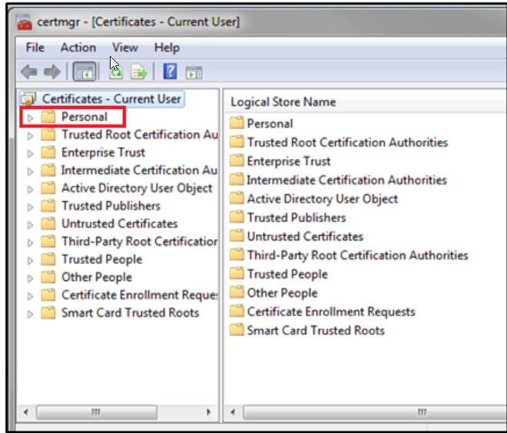

- Click All Tasks, then click Request New Certificate
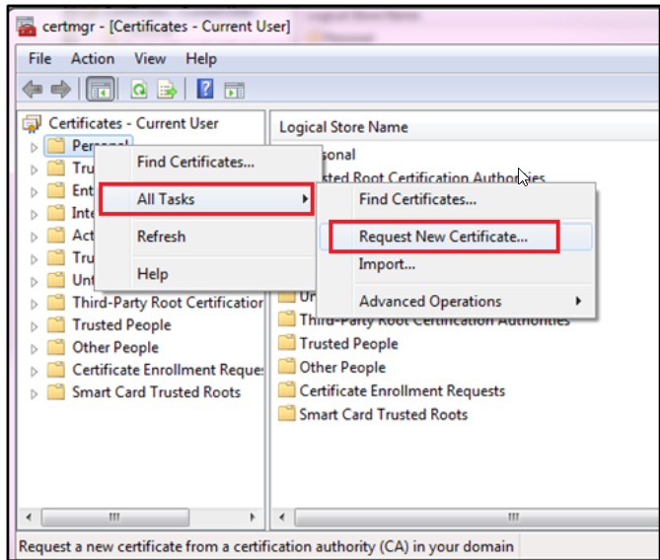

- Click Next
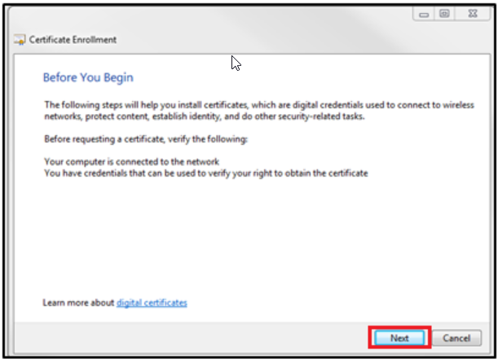

- Click Next
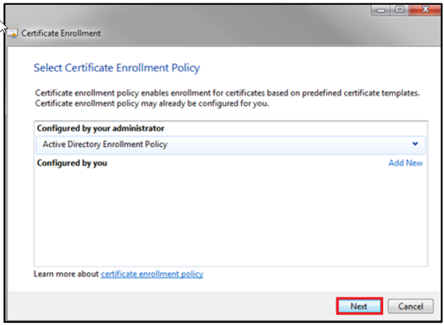

- Click box for GOA Digital Signature, then click Enroll. If GOA Digital Signature is not available choose GOA User, then click Enroll.

Validate a Signature

On the top toolbar of your Adobe Reader, click on the “Signature Panel” button. The Signature Panel shows you how many and which signatures need validating (if any):

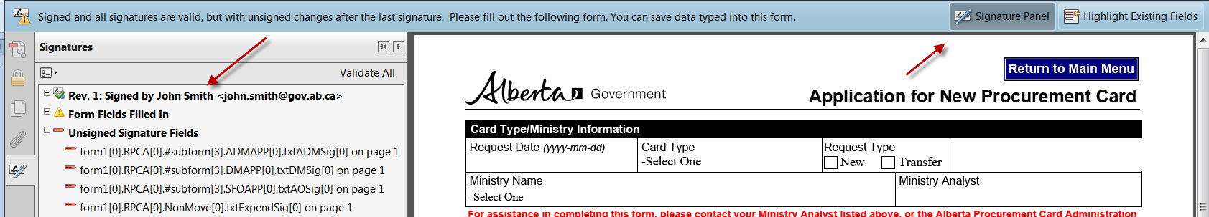

In this case with John’s signature it is valid as there is no error message and this is what appears when we expand the properties of his signature:
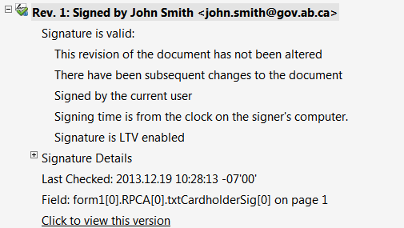

If a signature appears as invalid it will appear saying that the signature validity is UNKNOWN, like this:
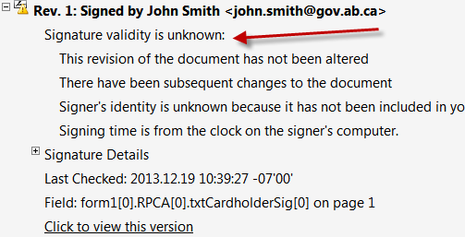

Configure Adobe Reader to Trust GoA Certificates
- From the Adobe Reader menu bar: Select “EDIT”, then “Preferences”
- The “Preferences” pop up box will appear. Click on “Signatures”, under the section “Verification” click the More… button
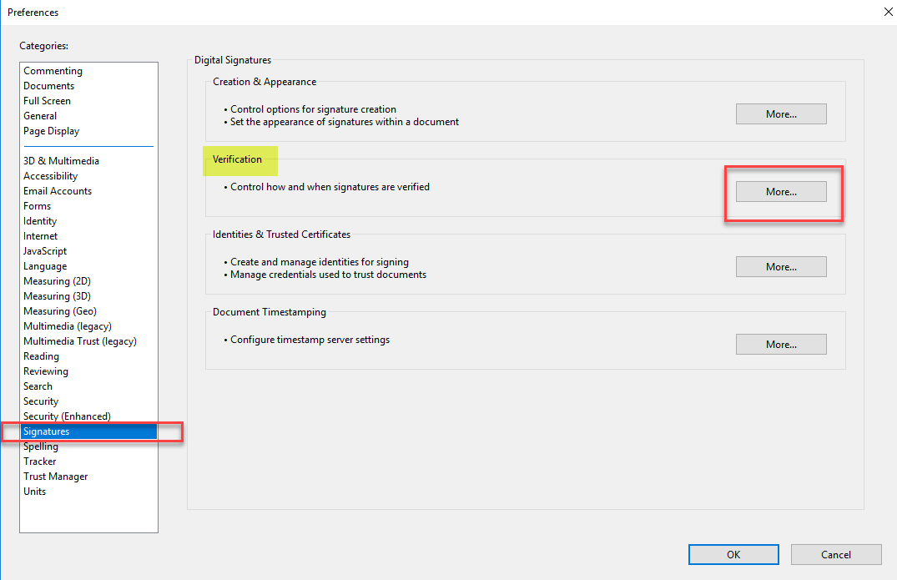
- A “Signature Verification Preferences” pop up box will appear. At the bottom, click on the box for “Validating Signatures”. Then Click OK.
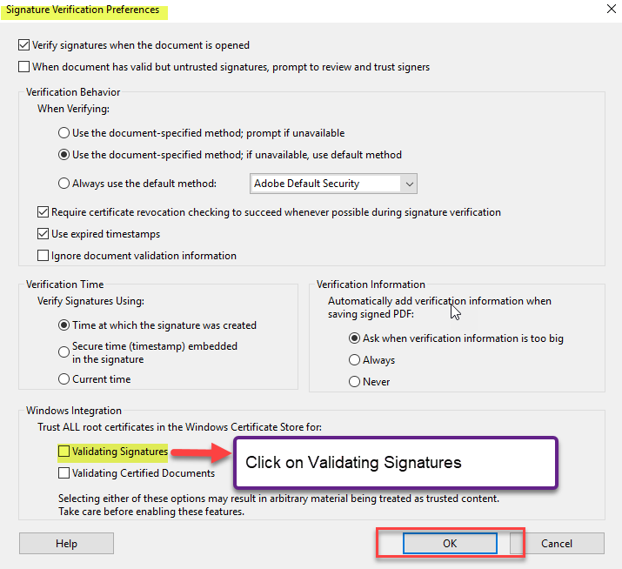

Manually Trust a Signature

Please ensure you follow the steps in Configure Adobe Reader to Trust GoA Certificates first. This should automatically trust all GoA issued signature certificates.

Note: Only perform these steps if you are certain that the correct individual applied the signature to the document.

- Click on the little icon underneath the Signatures heading to expand the selection list and choose “Show Signature Properties”:
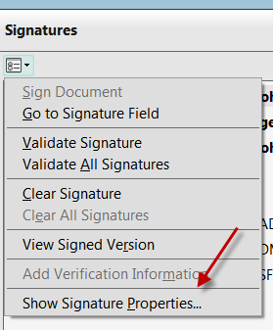

- Click on the “Show Signer’s Certificate” button:
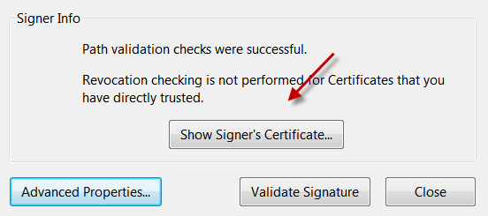

- On the Certificate Viewer window, click on the “Trust” tab and click on the “Add to Trusted Certificates” button. Adobe will ask you to confirm this action – click OK.
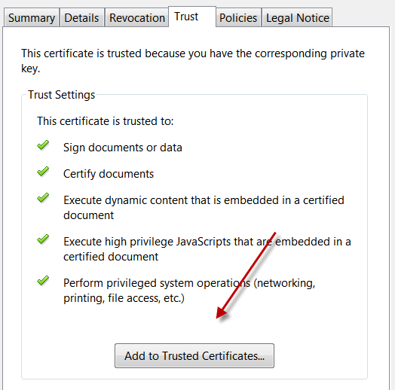

- On the Import Contact Settings window that appears, ensure that the “Use this Certificate as a Trusted Root” is selected and click OK.
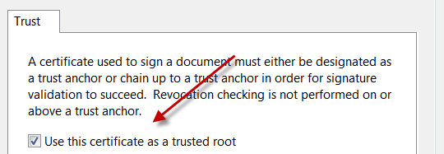

- Click OK on the Certificate Viewer window. Back on the Signature Panel, click on the “Validate Signature” button and then click “Close”.
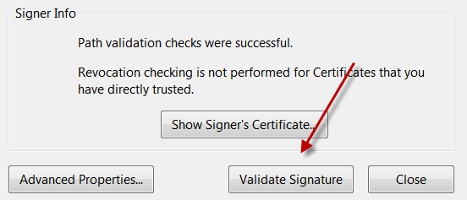

Your signature is validated.

